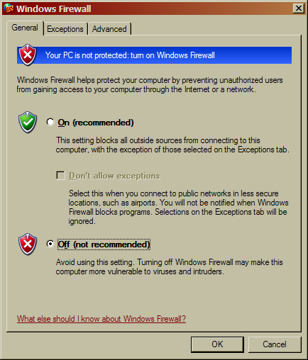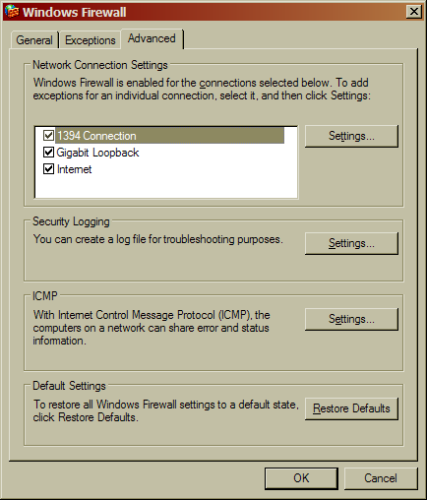
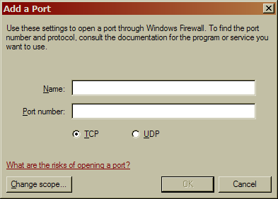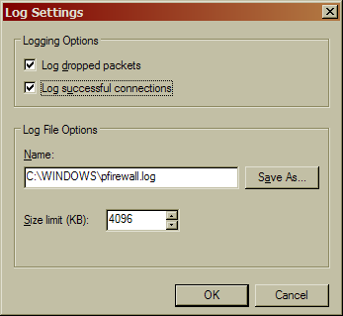
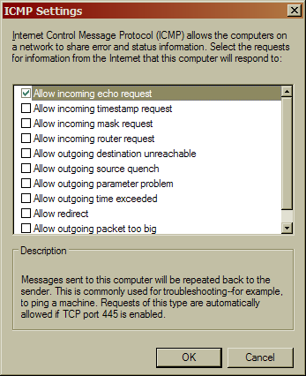
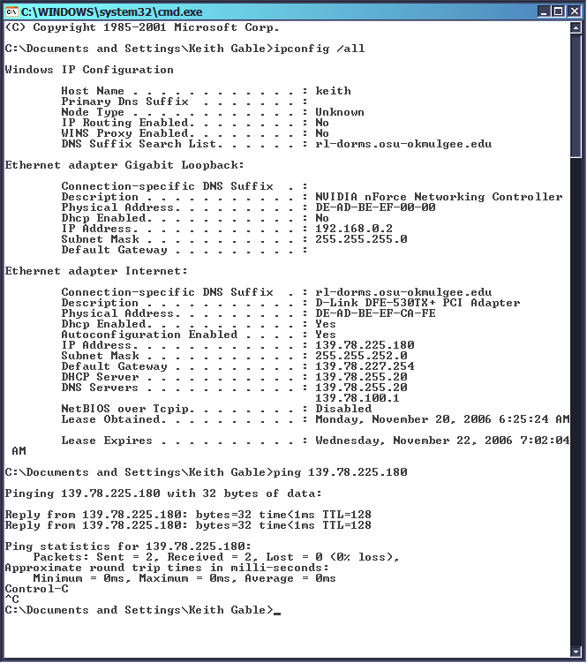

Summary
I use ZoneAlarm instead of the built-in Windows Firewall, because it’s better. ZoneAlarm allows pings, so that’s why it worked. Anyway, I didn’t know that Windows Firewall had logging options. I’ll keep that in mind in the future if I decide to ever set someone up with Windows Firewall. I still recommend ZoneAlarm over Windows Firewall simply because ZoneAlarm offers outbound protection. Another, totally unrelated thing to note is my MAC address.

